Java Project

**ACKNOWLEDGMENT**

First of all, I want to thank my parents for bringing me into this world, for raising me with such care and for sending me to such a great school. I would like to thank God for always being with me and looking over me as I live my life.

My many thanks to our computer applications teacher, Ms. Manali Dubal for teaching us the subject in such a great manner. I would like to give my special regards to my friends who helped me and my partner with this project – Het Parsania and Kushal Patel. They seasoned our project in very unique ways.

**ABSTRACT**

The driving goal was to make a fully functional code for a pseudo airline management company. The goal was achieved for the most part. Here is a brief description of the aspects we have covered.

**Buy/sell planes:** This part is the soul of the project. Here the user buys/sells planes out of 15 default choices.

**Route management:** This part allows you to assign routes amongst 15 default routes to already bought planes.

**Maintenance:** This part takes care of the planes already bought. It is divided into 4 types.

**Hangar:** This shows you the information of all owned planes.

**Advertisement:** This part enables you to advertise and market for the company.

**Catering:** This part enables you to organize parties and buffets to campaign for your company.

**Stocks:** This part is a minigame for the user where he has to buy and sell stocks and try to remain in profit

**Logout:** This part displays the overall bill for the whole code. Watch out for the easter egg.

**INDEX**

Contents

**PROGRAM** 4

**GLOSSARY** 32

**OUTPUT** 35

**CONCLUSION** 47

**BIBLIOGRAPHY** 48

# **PROGRAM**

import java.util.*;

class flight

{

Scanner scan = new Scanner(System.in);//declaring scanner class

//Global Variable

int count = 0;

//dashboard

String country_name;

String company_name;

String username;

String password;

//case 1

int aircraft_buying_price[] = new int[100];

int aircraft_price_num[] = new int[15];

String aircraft_name[] = new String[15];

String aircraft_price_word[] = new String[15];

String aircraft_capacity[] = new String[15];

String aircraft_bought[] = new String[100];

String airplane_choice;

String buy_sell_logout;

int total_bill_buy_sell;

int count_buy = 0;

int total_buying_bill = 0;

int total_selling_bill = 0;

int choice_buy_plane = 0;

int choice_count_plane = 0;

int choice_sell_plane = 0;

//case 2

int aircrafts_routes_distance[] = new int[15];

String aircrafts_routes[] = new String[15];

int choice_routes = 0;

int choice_routes_aircraft = 0;

int choice_route_plane = 0;

int choice_route_plane_2 = 0;

int fuel_price = 0;

String plane_assigned[] = new String[100];

long routes_bill = 0;

//case 3

int choice_maintain_plane_2 = 0;

int choice_maintain_plane = 0;

int choice_maintain_plane_3 = 0;

int maintain_bill_1 = 0;

int maintain_bill_2 = 0;

int maintain_bill_3 = 0;

int maintain_bill_4 = 0;

int total_bill_maintain = 0;

String maintain_logout;

// case 5

String market_logout;

int marketing_choice = 0;

int kiosk_number;

int kiosk_time;

int hoarding_number = 0;

int hoarding_time = 0;

int ad_time = 0;

int ad_channel = 0;

int ad_number = 0;

int campaign_number = 0;

int campaign_time = 0;

long kiosk_bill = 0;

long hoarding_bill = 0;

long ad_bill = 0;

long campaign_bill = 0;

long total_bill_advertisement = 0;

// case 6

int catering_choice = 0;

int osteria_number = 0;

int osteria_time = 0;

int celler_channel = 0;

int celler_time = 0;

int celler_number = 0;

int mirazur_number = 0;

int eleven_number = 0;

int eleven_time = 0;

long osteria_bill = 0;

long celler_bill = 0;

long mirazur_bill = 0;

long eleven_bill = 0;

long total_bill_catering = 0;

String catering_logout;

//case 7

int stock_owned = 0;

int stock_owned_1 = 0;

int stock_price_2 = 0;

int stock_buy = 0;

int total = 0;

int stock_sell = 0;

int stock_max = 500;

double stock_bill = 0;

double stock_price = 0;

String stock_choice_2;

String stock_choice_3;

//case 8

int final_bill = 0;

double easter_egg = 0;

String choice_logout;

String credit_card_number;

void Login()

{

System.out.println("*-----------------------------------------------*");

System.out.print("*Write your company name:-    ");

company_name = scan.nextLine();

System.out.println("*-----------------------------------------------*");

System.out.print("*Username-                    ");

username = scan.next(); //validation done

System.out.println("------------------------------------------------*");

System.out.print("*Password-                    ");

password = scan.next();

System.out.println("*-----------------------------------------------*");

if ((password.equalsIgnoreCase("admin")) && (Character.isAlphabetic(username.charAt(0))))

{

System.out.println("*Access Granted!                                *");

System.out.println("*-----------------------------------------------*");

System.out.println("****************************************************

********");

}

else

{

System.out.println("*Access Denied!                                 *");

System.out.println("*-----------------------------------------------*");

System.out.println("****************************************************

****");

System.exit(0);

}

System.out.println("*Welcome to " + company_name + " Pvt. Ltd.*");

System.out.println("*Select a city from which you want to start the company.*"); System.out.print("*Enter the name of the city:- ");

country_name = scan.next();

System.out.println("************************************************************");

}

void Case_1() //Buy or sell plane

{

aircraft_name[0] = "Aerospatiale 72-600        ";

aircraft_name[1] = "Airbus 350-800             ";

aircraft_name[2] = "Airbus A380                ";

aircraft_name[3] = "Boeing 717-200             ";

aircraft_name[4] = "Boeing 747 400             ";

aircraft_name[5] = "Boeing 777-200LR           ";

aircraft_name[6] = "Comac C919                 ";

aircraft_name[7] = "McDonnell Douglas MD-80    ";

aircraft_name[8] = "McDonnell Douglas-11ER     ";

aircraft_name[9] = "Sukhoi KR-860              ";

aircraft_name[10] = "Airbus Beluga             ";

aircraft_name[11] = "Antonov An-124 Ruslan     ";

aircraft_name[12] = "Antonov An-22             ";

aircraft_name[13] = "Boeing C-17 Globemaster III    ";

aircraft_name[14] = "Lockheed C-5 Galaxy            ";

aircraft_price_word[0] = "$445.6 million      ";

aircraft_price_word[1] = "$240 million        ";

aircraft_price_word[2] = "$50 million         ";

aircraft_price_word[3] = "$50 million         ";

aircraft_price_word[4] = "$22.7 million       ";

aircraft_price_word[5] = "$317.4 million      ";

aircraft_price_word[6] = "$74.48 million      ";

aircraft_price_word[7] = "$17 million         ";

aircraft_price_word[8] = "$147.5 million      ";

aircraft_price_word[9] = "$444.04 million     ";

aircraft_price_word[10] = "$204.3 million      ";

aircraft_price_word[11] = "$262.75 million     ";

aircraft_price_word[12] = "$204 million        ";

aircraft_price_word[13] = "$254 million        ";

aircraft_price_word[14] = "$218 million        ";

aircraft_price_num[0] = 445600000;

aircraft_price_num[1] = 240000000;

aircraft_price_num[2] = 500000000;

aircraft_price_num[3] = 500000000;

aircraft_price_num[4] = 227000000;

aircraft_price_num[5] = 317400000;

aircraft_price_num[6] = 744800000;

aircraft_price_num[7] = 170000000;

aircraft_price_num[8] = 147500000;

aircraft_price_num[9] = 444040000;

aircraft_price_num[10] = 204300000;

aircraft_price_num[11] = 262700000;

aircraft_price_num[12] = 204000000;

aircraft_price_num[13] = 254000000;

aircraft_price_num[14] = 218000000;

aircraft_capacity[0] = "853 passengers    ";

aircraft_capacity[1] = "700 Passengers    ";

aircraft_capacity[2] = "330 Passengers    ";

aircraft_capacity[3] = "330 Passengers    ";

aircraft_capacity[4] = "74 passangers     ";

aircraft_capacity[5] = "270 passengers    ";

aircraft_capacity[6] = "300 passengers    ";

aircraft_capacity[7] = "106 passengers    ";

aircraft_capacity[8] = "410 passengers    ";

aircraft_capacity[9] = "860 passengers    ";

aircraft_capacity[10] = "90 tonnes         ";

aircraft_capacity[11] = "138 tonnes        ";

aircraft_capacity[12] = "122.5 tonnes      ";

aircraft_capacity[13] = "140 tonnes        ";

aircraft_capacity[14] = "127.5 tonnes      ";

buy_sell: for (;;)

{

System.out.println("*************************************");

System.out.println("*what action would you like to make:*");

System.out.println("*buy planes................(press b)*");

System.out.println("*sell planes...............(press s)*");

System.out.println("*exit to home page.........(press e)*");

System.out.println("*************************************");

airplane_choice = scan.next().toLowerCase(); // Buy or sell plane

switch (airplane_choice)

{

case "b":

System.out.println("***********************************************************************************************************");

for (count = 0; count < 15; count++)

{

System.out.println("*---------------------------------------------------------------------------------------------------------");

System.out.println("*|" + aircraft_name[count] + "  " +

aircraft_capacity[count] + "  " + aircraft_price_word[count] + ".......Press " + count);

}

System.out.println("*---------------------------------------------------------------------------------------------------------*");

System.out.println("***********************************************************************************************************");

System.out.print("*how many Aircrafts do you want to Buy-");

choice_count_plane = scan.nextInt();

System.out.println("***************************************");

if (choice_count_plane > 0)

{

for (count = 0; count < choice_count_plane; count++,

count_buy++)

{

System.out.println("*********************************");

System.out.println("*Which plane do you want to buy *");

System.out.print("*Enter the choice-");

choice_buy_plane = scan.nextInt();

System.out.println("*********************************")

aircraft_bought[count_buy] = aircraft_name[choice_buy_plane];

aircraft_buying_price[count_buy] = aircraft_price_num[choice_buy_plane];

total_buying_bill = total_buying_bill + aircraft_price_num[choice_buy_plane];

}

System.out.println("=========================================================");

System.out.println("Your total bill is:- Rs." + total_buying_bill);

System.out.println("=========================================================");

break;

}

elsse

break;

case "s":

if (aircraft_bought.length > 0)

{

System.out.println("**************************************************************");

for (count = 0; count < aircraft_bought.length; count++)

{

if (aircraft_buying_price[count] == 0)

{

break;

}

System.out.println("*---------------------------------------------------------------------------------------------------------*");

System.out.println("*|" + aircraft_bought[count] + "     " +

aircraft_buying_price[count] + ".......Press " + count + "*");

}

System.out.println("**************************************************************");

System.out.println("--------------------------------------");

System.out.print("how many Aircrafts do you want to sell-");

choice_count_plane = scan.nextInt();

System.out.println("**********************************");

for (count = 0; count < choice_count_plane; count++)

{

System.out.println("*Which planes do you want to

sell*");

System.out.print("*Enter the choice-");

choice_sell_plane = scan.nextInt();

aircraft_bought[choice_sell_plane] = "Sold";

total_selling_bill = (total_selling_bill +

aircraft_buying_price[choice_sell_plane]) * -1;

aircraft_buying_price[choice_sell_plane] = 0000;

}

System.out.println("**********************************");

System.out.println("=========================================================");

System.out.println("Your total bill is:-  Rs." + total_selling_bill);

System.out.println("=========================================================");

break;

}

else if (aircraft_bought.length == 0)

{

System.out.println("******************************");

System.out.println("*You do not own any aircrafts*");

System.out.println("******************************");

return;

}

case "e":

System.out.println("***********************************");

System.out.println("*Are You Sure!!!.............(y/n)*");

System.out.println("***********************************");

buy_sell_logout = scan.next().toLowerCase();

total_bill_buy_sell = total_buying_bill + total_selling_bill;

if (buy_sell_logout.equals("y"))

{

System.out.println("=================================================");

System.out.println(" Bill = Rs." + total_bill_buy_sell + "    "); //bill

System.out.println("=================================================");

break buy_sell ; //break infinite loop to go directly to dashboard loop

}

else if (buy_sell_logout.equals("n"))

{

break;

}

break;

default:

System.out.println("*************************************");

System.out.println("*Please choose an appropriate letter*");

System.out.println("*************************************");

System.out.print("\n");

break;

}

}

}

void Case_2()//Route management

{

aircrafts_routes[0] = " to Bangkok     ";

aircrafts_routes[1] = " to Brazil      ";

aircrafts_routes[2] = " to Congo       ";

aircrafts_routes[3] = " to Dubai       ";

aircrafts_routes[4] = " to Hong kong   ";

aircrafts_routes[5] = " to Las Vegas   ";

aircrafts_routes[6] = " to London      ";

aircrafts_routes[7] = " to Los Angeles ";

aircrafts_routes[8] = " to New York    ";

aircrafts_routes[9] = " to Paris       ";

aircrafts_routes[10] = " to Singapore   ";

aircrafts_routes[11] = " to Sydney      ";

aircrafts_routes[12] = " to Tokyo       ";

aircrafts_routes[13] = " to Torronto    ";

aircrafts_routes[14] = " to Venezuela   ";

aircrafts_routes_distance[0] = 3040;

aircrafts_routes_distance[1] = 13760;

aircrafts_routes_distance[2] = 6570;

aircrafts_routes_distance[3] = 1941;

aircrafts_routes_distance[4] = 4280;

aircrafts_routes_distance[5] = 13820;

aircrafts_routes_distance[6] = 7220;

aircrafts_routes_distance[7] = 14000;

aircrafts_routes_distance[8] = 12450;

aircrafts_routes_distance[9] = 7000;

aircrafts_routes_distance[10] = 3920;

aircrafts_routes_distance[11] = 10160;

aircrafts_routes_distance[12] = 6740;

aircrafts_routes_distance[13] = 12500;

aircrafts_routes_distance[14] = 14540;

route: for (;;)

{

fuel_price = (int)(Math.random() * 1000);

System.out.println("*******************************************************");

System.out.println("*current fuel price is:- RS." + fuel_price + "                        *");

System.out.println("*******************************************************");

for (count = 0; count <= 99999999; count++) {} //delay loop

for (count = 0; count < aircraft_bought.length; count++)

{

if (aircraft_bought[count] == null)

{

if (count == 0)

{

System.out.println("******************************");

System.out.println("*You do not own any aircrafts*");

System.out.println("******************************");

return;

}

break;

}

System.out.println("************************************************************************");

System.out.println("*----------------------------------------------------------------------*");

System.out.println("*|" + aircraft_bought[count] + "     .......Press " + count);

}

System.out.println("************************************************************************");

System.out.println("*Choose number of plane you want to assign routes.*");

System.out.println("***************************************************");

choice_route_plane = scan.nextInt();

System.out.println("************************************");

for (count = 0; count < choice_route_plane; count++)

{

System.out.println("*----------------------------------*");

System.out.println("*Which plane do you want to assign *");

System.out.print("*Enter the choice-");

choice_route_plane_2 = scan.nextInt();

plane_assigned[count] = aircraft_bought[choice_route_plane_2];

}

System.out.println("************************************");

System.out.println("*******************************************************");

System.out.println("*You can only buy " + choice_route_plane + " routes *");

System.out.println("*******************************************************");

for (count = 0; count < 15; count++)

{

System.out.println("---------------------------------------------------------------------------");

System.out.println(country_name + "" + aircrafts_routes[count] + "  ..... Press-" + count);

}

System.out.println("---------------------------------------------------------------------------");

for (count = 1; count <= choice_route_plane; count++)

{

System.out.println("---------------------------------------------------------------------------");

System.out.println("pick the route you want");

choice_routes = scan.nextInt();

routes_bill = routes_bill + ((int)(aircrafts_routes_distance[choice_routes] / 5) * fuel_price);

}

System.out.println("=========================================================");

System.out.println("Bill:- Rs." + routes_bill);

System.out.println("=========================================================");

break;

}

}

void Case_3()//Maintenance

{

for (count = 0; count < aircraft_bought.length; count++)

{

if (aircraft_bought[count] == null)

{

if (count == 0)

{

System.out.println("******************************");

System.out.println("*You do not own any aircrafts*");

System.out.println("******************************");

return;

}

break;

}

System.out.println("************************************************************************");

System.out.println("*----------------------------------------------------------------------*");

System.out.println("*|" + aircraft_bought[count] + "     .......Press " + count + " *");

}

System.out.println("************************************************************************");

System.out.println("*Choose number of plane you want to maintain.*");

System.out.println("**********************************************");

choice_maintain_plane = scan.nextInt();

System.out.println("********************************************");

for (count = 0; count < choice_maintain_plane; count++)

{

System.out.println("*Which planes do you want to mainatain     *");

System.out.print("*Enter your choice-");

choice_maintain_plane_2 = scan.nextInt();

plane_assigned[count] = aircraft_bought[choice_maintain_plane_2];

}

System.out.println("********************************************");

maintain: for (;;)

{

System.out.println("**************************************************************");

System.out.println("*What type of maintenance do you want your planes to undergo?*");

System.out.println("*General maintenance.......(press 1)                         *");

System.out.println("*Engine maintenance........(press 2)                         *");

System.out.println("*Cleaning maintenance......(press 3)                         *");

System.out.println("*Wing maintenance..........(press 4)                         *");

System.out.println("*Logout....................(press 5)                         *");

System.out.println("**************************************************************");

choice_maintain_plane_3 = scan.nextInt();

switch (choice_maintain_plane_3)

{

case 1:

System.out.println("******************************************************");

System.out.println("*Cost of General maintenance per plane = Rs.10,00,000*");

System.out.println("******************************************************");

maintain_bill_1 = choice_maintain_plane * 1000000;

System.out.println("======================================================");

System.out.println("Your Bill = Rs." + maintain_bill_1);

System.out.println("======================================================");

break;

case 2:

System.out.println("******************************************************");

System.out.println("*Cost of Engine maintenance per plane = Rs.9,45,000  *");

System.out.println("******************************************************");

maintain_bill_2 = choice_maintain_plane * 945000;

System.out.println("======================================================");

System.out.println("Your Bill = Rs." + maintain_bill_2);

System.out.println("======================================================");

break;

case 3:

System.out.println("******************************************************");

System.out.println("*Cost of Cleaning maintenance per plane = Rs.6,30,000*");

System.out.println("******************************************************");

maintain_bill_3 = choice_maintain_plane * 630000;

System.out.println("======================================================");

System.out.println("Your Bill = Rs." + maintain_bill_3);

System.out.println("======================================================");

break;

case 4:

System.out.println("******************************************************");

System.out.println("*Cost of Wing maintenance per plane = Rs.8,10,000    *");

System.out.println("******************************************************");

maintain_bill_4 = choice_maintain_plane * 810000;

System.out.println("======================================================");

System.out.println("Your Bill = Rs." + maintain_bill_4);

System.out.println("======================================================");

break;

case 5:

System.out.println("***********************************");

System.out.println("*Are You Sure!!!.............(y/n)*");

System.out.println("***********************************");

maintain_logout = scan.next().toLowerCase();

total_bill_maintain = maintain_bill_1 + maintain_bill_2 + maintain_bill_3 + maintain_bill_4;

if (maintain_logout.equals("y"))

{

System.out.println("=========================================================");

System.out.println("Bill = Rs." + total_bill_maintain); //bill

System.out.println("=========================================================");

break maintain; //break infinite loop to go directly to dashboard loop

}

else

{

return;

}

default:

System.out.println("*************************************");

System.out.println("*Please choose an appropriate letter*");

System.out.println("*************************************");

System.out.print("\n");

}

}

}

void Case_4()//Hanger management

{

System.out.println("**********************");

System.out.println("*You have " + choice_count_plane + " Aircrafts*");

if (choice_count_plane > 0)

{

System.out.println("*You have:-          *");

System.out.println("**********************");

for (count = 0; count < (choice_count_plane + 10); count++)

{

if (aircraft_bought[count] == null)

{

return;

}

else

{

System.out.println("---------------------------------------------");

System.out.println("Plane no. " + count + "          " + aircraft_bought[count]);

System.out.println("---------------------------------------------");

}

}

System.out.println("---------------------------------------------------------");

}

else

{

System.out.println("*****************************");

System.out.println("* No planes in your Hanger *");

System.out.println("*****************************");

return;

}

}

void Case_5()//Advertisement

{

market: for (;;) // naming loop to break in future

{

System.out.println("****************************************");

System.out.println("* How would you like to advertise?     *");

System.out.println("* Kiosk......................(press 1) *");

System.out.println("* Hoarding...................(press 2) *");

System.out.println("* Advertisement..............(press 3) *");

System.out.println("* Campaign...................(press 4) *");

System.out.println("* Logout.....................(press 5) *");

System.out.println("****************************************");

marketing_choice = scan.nextInt();

switch (marketing_choice)

{

case 1:

System.out.println("*************************************************");

System.out.println("* Base price per kiosk = Rs.4500 per month      *");

System.out.println("* Offers include:                               *");

System.out.println("* 5% discount on 150 kiosk or less per month    *");

System.out.println("* 10% discount on 150 kiosk or more per month   *");

System.out.println("* How many kiosk would you like to buy?         *");

System.out.println("*************************************************");

kiosk_number = scan.nextInt();

System.out.println("**********************");

System.out.println("*For how many months?*");

System.out.println("**********************");

kiosk_time = scan.nextInt();

if (kiosk_number <= 150)

{

kiosk_bill = kiosk_bill + (Math.round(kiosk_number * kiosk_time * 0.95 * 4500));

}

else

{

kiosk_bill = kiosk_bill + (Math.round(kiosk_number * kiosk_time * 0.9 * 4500));

}

System.out.println("=========================================================");

System.out.println("Your bill = Rs." + kiosk_bill);

System.out.println("=========================================================");

break;

case 2:

System.out.println("***************************************************************");

System.out.println("* Base price per month = Rs.5,00,000                          *");

System.out.println("* Offers include:                                             *");

System.out.println("* 40 x 12 ft or 12.19 x 3.66 m for Rs.45,00,000.....(press 1) *");

System.out.println("* 48 x 14 ft or 14.63 x 4.27 m for Rs.50,00,000.....(press 2) *");

System.out.println("* 50 x 20 ft or 15.24 x 6.10 m for Rs.57,00,000.....(press 3) *");

System.out.println("* 60 x 16 ft or 18.29 x 4.88 m for Rs.66,00,000.....(press 4) *");

System.out.println("* Which billboard would you like to buy?                      *");

System.out.println("***************************************************************");

hoarding_number = scan.nextInt();

System.out.println("**********************");

System.out.println("*For how many months?*");

System.out.println("**********************");

hoarding_time = scan.nextInt();

if (hoarding_number == 1)

{

hoarding_bill = hoarding_bill + (4500000 + (hoarding_time * 500000));

}

else if (hoarding_number == 2)

{

hoarding_bill = hoarding_bill + (5000000 + (hoarding_time * 500000));

}

else if (hoarding_number == 3)

{

hoarding_bill = hoarding_bill + (5700000 + (hoarding_time * 500000));

}

else if (hoarding_number == 4)

{

hoarding_bill = hoarding_bill + (6600000 + (hoarding_time * 500000));

}

else

{

System.out.println("=========================================================");

System.out.println("Your bill = Rs." + hoarding_bill);

System.out.println("=========================================================");

break;

}

System.out.println("=========================================================");

System.out.println("Your bill = Rs." + hoarding_bill);

System.out.println("=========================================================");

break;

case 3:

System.out.println("***********************************************************");

System.out.println("* Base price per advertisement = Rs.11000 per second      *");

System.out.println("* How long do you want the advertisement?....(in seconds) *");

System.out.println("***********************************************************");

ad_time = scan.nextInt();

System.out.println("*****************************************************************");

System.out.println("* Channels include:                                             *");

System.out.println("* Saab tv - Rs.50,000 per ad..........................(press 1) *");

System.out.println("* Sunny entertainment television - Rs.55,000 per ad...(press 2) *");

System.out.println("* Coloury tv  - Rs.60,000 per ad......................(press 3) *");

System.out.println("* Which channel do you choose?                                  *");

System.out.println("*****************************************************************");

ad_channel = scan.nextInt();

System.out.println("**********************************************");

System.out.println("*How many times do you want the ad to appear?*");

System.out.println("**********************************************");

ad_number = scan.nextInt();

if (ad_channel == 1)

{

ad_bill = ad_bill + (ad_time * 11000) + (50000 * ad_number);

}

else if (ad_channel == 2)

{

ad_bill = ad_bill + (ad_time * 11000) + (55000 * ad_number);

}

else if (ad_channel == 3)

{

ad_bill = ad_bill + (ad_time * 11000) + (60000 * ad_number);

}

else

{

System.out.println("=========================================================");

System.out.println("Your bill = Rs." + ad_bill);

System.out.println("=========================================================");

break;

}

break;

case 4:

System.out.println("****************************************************************");

System.out.println("* Base price per campaign = Rs.50,00,000                       *");

System.out.println("* Offers include:                                              *");

System.out.println("* Invite 100 people for Rs.70,00,000 per day..........(press 1) *");

System.out.println("* Invite 250 people for Rs.90,00,000 per day.........(press 2) *");

System.out.println("* Invite 500 people for Rs.1,30,00,000 per day.......(press 3) *");

System.out.println("* Invite 1000 people for Rs.2,00,00,000 per day......(press 4) *");

System.out.println("* Which campaign would you like to host?                       *");

System.out.println("****************************************************************");

campaign_number = scan.nextInt();

System.out.println("For how many days?");

campaign_time = scan.nextInt();

if (campaign_number == 1)

{

campaign_bill = campaign_bill + 5000000 + (campaign_time * 700000);

}

else if (campaign_number == 2)

{

campaign_bill = campaign_bill + 5000000 + (campaign_time * 900000);

}

else if (campaign_number == 3)

{

campaign_bill = campaign_bill + 5000000 + (campaign_time * 13000000);

}

else if (campaign_number == 4)

{

campaign_bill = campaign_bill + 5000000 + (campaign_time * 20000000);

}

else

System.out.println("=========================================================");

System.out.println("Your bill = Rs." + campaign_bill);

System.out.println("=========================================================");

break;

case 5:

System.out.println("***********************************");

System.out.println("*Are You Sure!!!.............(y/n)*");

System.out.println("***********************************");

market_logout = scan.next().toLowerCase();

total_bill_advertisement = kiosk_bill + ad_bill + hoarding_bill + campaign_bill;

(market_logout.equals("y"))

{

System.out.println("=================================================");

System.out.println(" Bill = Rs." + total_bill_advertisement + "    "); //bill

System.out.println("=================================================");

break market; //break infinite loop to go directly to dashboard loop

}

else if (market_logout.equals("n"))

{

break;

}

break;

Default:

System.out.println("*************************************");

System.out.println("*Please choose an appropriate letter*");

System.out.println("*************************************");

System.out.print("\n");

break;

}

}

}

void Case_6() // Catering

{

catering:for(;;)//naming loop to break in future

{

System.out.println("****************************************");

System.out.println("* Which food service would you like?   *");

System.out.println("* Osteria Francescana........(press 1) *");

System.out.println("* El Celler de Can Roca .....(press 2) *");

System.out.println("* Mirazur....................(press 3) *");

System.out.println("* Eleven Mcellerison Park....(press 4) *");

System.out.println("* logout.....................(press 5) *");

System.out.println("****************************************");

catering_choice = scan.nextInt();

switch (catering_choice)

{

case 1:

System.out.println("******************************************************");

System.out.println("* Base price per plate = Rs.5,000                    *");

System.out.println("* Offers include:                                    *");

System.out.println("* Class III plate for Rs.5000 per plate....(press 1) *");

System.out.println("* Class II plate for Rs.5700 per plate.....(press 2) *");

System.out.println("* Class I plate for Rs.6800 per plate......(press 3) *");

System.out.println("* Buffet for Rs.7200 per plate.............(press 4) *");

System.out.println("* Logout                                   (press 5) *");

System.out.println("* Which service would you like to buy?               *");

System.out.println("******************************************************");

osteria_number = scan.nextInt();

if (osteria_number == 5)

{

System.out.println("=========================================================");

System.out.println("Your bill = Rs." + osteria_bill);

System.out.println("=========================================================");

break;

}

System.out.println("*********************");

System.out.println("*For how many plates?*");

System.out.println("*********************");

osteria_time = scan.nextInt();

if (osteria_number == 1)

{

osteria_bill = osteria_bill + (osteria_time * 10000);

}

else if (osteria_number == 2)

{

osteria_bill = osteria_bill + (osteria_time * 10700);

}

else if (osteria_number == 3)

{

osteria_bill = osteria_bill + (osteria_time * 11800);

}

else if (osteria_number == 4)

{

osteria_bill = osteria_bill + (osteria_time * 12200);

}

else

{ break; }

System.out.println("=========================================================");

System.out.println("Your bill = Rs." + osteria_bill);

System.out.println("=========================================================");

break;

case 2:

System.out.println("********************************************");

System.out.println("* Base price per plate = Rs.8000 per plate *");

System.out.println("* How many plates do you want to serve?    *");

System.out.println("********************************************");

celler_time = scan.nextInt();

System.out.println("******************************************************************************"); System.out.println("* Buffets include:                                                           *"); System.out.println("* First + middle + dessert - Rs.50,00,000..........................(press 1) *"); System.out.println("* Starters + first + middle + dessert - Rs.55,00,000...............(press 2) *");

System.out.println("* Starters + first + middle + beverage + dessert - Rs.60,00,00.....(press 3) *");

System.out.println("* Logout                                                           (press 4) *");

System.out.println("* Which service do you choose?                                               *"); System.out.println("******************************************************************************"); celler_channel = scan.nextInt();

if (celler_channel == 4)

{

System.out.println("=========================================================");

System.out.println("Your bill = Rs." + celler_bill);

System.out.println("=========================================================");

break;

}

if (celler_channel == 1)

{

celler_bill = celler_bill + (celler_time * 8000) + 5000000;

}

else if (celler_channel == 2)

{

celler_bill = celler_bill + (celler_time * 88000) + 5500000;

}

else if (celler_channel == 3)

{

celler_bill = celler_bill + (celler_time * 8000) + 6000000;

}

else  break;

System.out.println("=========================================================");

System.out.println("Your bill = Rs." + celler_bill);

System.out.println("=========================================================");

break;

case 3:

System.out.println("*******************************************************");

System.out.println("* Base price per plate = Rs.9000                      *");

System.out.println("* Parties include:                                    *");

System.out.println("* Invite 100 people for Rs.7,00,000.........(press 1) *");

System.out.println("* Invite 250 people for Rs.9,00,000.........(press 2) *");

System.out.println("* Invite 500 people for Rs.13,00,000........(press 3) *");

System.out.println("* Invite 1000 people for Rs.20,00,000.......(press 4) *");

System.out.println("* Logout                                    (press 5) *");

System.out.println("* Which party would you like to host?                 *");

System.out.println("*******************************************************");

mirazur_number = scan.nextInt();

if (mirazur_number==5)

{

System.out.println("=========================================================");

System.out.println("Your bill = Rs." + mirazur_bill);

System.out.println("=========================================================");

break;

}

if (mirazur_number == 1)

{

mirazur_bill = mirazur_bill+ 900000 + 700000;

}

else if (mirazur_number == 2)

{

mirazur_bill = mirazur_bill+ 2250000 + 900000;

}

else if (mirazur_number == 3)

{

mirazur_bill = mirazur_bill+ 4500000 + 1300000;

}

else if (mirazur_number == 4)

{

mirazur_bill = mirazur_bill + 9000000 + 2000000;

}

else break;

System.out.println("=========================================================");

System.out.println("Your bill = Rs." + mirazur_bill);

System.out.println("=========================================================");

break;

case 4:

System.out.println("**************************************************");

System.out.println("* Base price per plate = Rs.10000 per plate      *");

System.out.println("* Offers include:                                *");

System.out.println("* 5% discount on 10 items or less                *");

System.out.println("* 10% discount on 10 items or more               *");

System.out.println("* Logout                               (press 9) *");

System.out.println("* How many menu items would you like to buy?     *");

System.out.println("**************************************************");

eleven_number = scan.nextInt();

if (eleven_number==9)

{

System.out.println("================================================");

System.out.println("Your bill = Rs." + eleven_bill);

System.out.println("================================================");

break;

}

System.out.println("*********************");

System.out.println("*For how many plates?*");

System.out.println("*********************");

eleven_time = scan.nextInt();

if (eleven_number <= 150)

{

eleven_bill = Math.round(eleven_number * eleven_time * 0.95 * 10000);

}

else

{

eleven_bill = Math.round(eleven_number * eleven_time * 0.9 * 1000);

}

System.out.println("================================================");

System.out.println("Your bill = Rs." + eleven_bill);

System.out.println("================================================");

break;

case 5:

System.out.println("***********************************");

System.out.println("*Are You Sure!!!.............(y/n)*");

System.out.println("***********************************");

catering_logout = scan.next().toLowerCase();

total_bill_catering = eleven_bill + celler_bill + osteria_bill + mirazur_bill;

if (catering_logout.equals("y"))

{

System.out.println("*********************************************************");

System.out.println("*Bill = Rs." + total_bill_catering); //bill

System.out.println("*********************************************************");

break catering; //break infinite loop to go directly to dashboard loop

}

else if (catering_logout.equals("n"))

{ break; }

break;

Default:

System.out.println("*************************************");

System.out.println("*Please choose an appropriate letter*");

System.out.println("*************************************");System.out.println("\n");

break;

}

}

}

void Case_7()// Stocks

{

for (;;)

{

System.out.println("*****************************************************************");

System.out.println("*The current price for the stocks is $6000                      *");

stock_price = 6000.0;

System.out.println("*                                                               *");

System.out.println("*Would you like to buy stocks at the base price?.....(yes/exit) *"); System.out.println("*****************************************************************");

stock_choice_2 = scan.next().toLowerCase();

if (stock_choice_2.equals("yes"))

{

System.out.print("\n");

System.out.println("******************************");

System.out.println("*Buy upto 500 shares only    *");

System.out.println("*How many do you want to buy?*");

System.out.println("******************************");

stock_owned += total;

stock_owned += scan.nextInt();

stock_bill = stock_owned * stock_price;

stock_price_2 = (int)((Math.random()) * 10000);

System.out.println("***********************************************");

System.out.println("*your new price is $" + stock_price_2);

System.out.println("***************************************************************************");

System.out.println("*Would you like to buy or sell or exit stocks at second price?.....(b/s/e)*");

System.out.println("***************************************************************************");

stock_choice_3 = scan.next().toLowerCase();

if (stock_choice_3.equals("b"))

{

System.out.println("**********************************");

System.out.println("*How many do you want to buy?    *");

System.out.println("**********************************");

stock_buy = scan.nextInt();

stock_bill += stock_buy * stock_price_2;

stock_owned += stock_buy;

System.out.println("================================================");

System.out.println("YOUR BILL IS $" + stock_bill);

System.out.println("YOU HAVE TOTAL " + stock_owned + " Stocks");

System.out.println("================================================");

}

else if (stock_choice_3.equalsIgnoreCase("s"))

{

for (;;)

{

System.out.println("**********************************");

System.out.println("*How many do you want to sell?   *");

System.out.println("**********************************");

stock_sell = scan.nextInt();

if (stock_owned >= stock_sell)

{

stock_bill -= (stock_sell * stock_price_2);

stock_owned -= stock_sell;

System.out.println("================================================");

System.out.println("YOUR BILL IS $" + stock_bill);

System.out.println("YOU HAVE TOTAL " + stock_owned + " Stocks");

System.out.println("================================================");

break;

}

else

{

System.out.println("********************************");

System.out.println("* You don't have enough stocks *");

System.out.println("********************************");

}

}

}

else if (stock_choice_3.equalsIgnoreCase("e"))

{

System.out.println("================================================");

System.out.println("YOUR BILL IS $" + stock_bill);

System.out.println("YOU HAVE TOTAL " + stock_owned + "Stocks");

System.out.println("================================================");

break;

}

}

else

{

break;

}

}

total += stock_owned;

}

void Case_8()//logout

{

easter_egg = (Math.random() * 10);

System.out.println("***********************************");

System.out.println("*Are You Sure!!!.............(y/n)*");

System.out.println("***********************************");

choice_logout = scan.next().toLowerCase();

final_bill = (int)(total_buying_bill + total_selling_bill + routes_bill + total_bill_maintain + total_bill_advertisement + total_bill_catering + stock_bill);

if (choice_logout.equalsIgnoreCase("y"))

{

easter: if (easter_egg >= 9.0)

{

System.out.println("==============================================");

System.out.println("Bill = Rs. " + final_bill); //bill

System.out.println("==============================================");

System.out.println("\n");

System.out.println("Hurray!!!!!!!  You have the Easter egg. ");

System.out.println("Enter your Credit Card Number                 ");

credit_card_number = scan.next().toLowerCase();

cc: for (;;)

{

if (credit_card_number.length() == 16)

{

System.out.println("********************************************************");

System.out.println("*------------------------------------------------------*");

System.out.println("*10% of Bill is added to this credit card.             *");

System.out.println("*------------------------------------------------------*");

System.out.println("########################################################");

System.out.println("#Complied by Kushal Patel, Keyur Padia and Het Parsania#");

System.out.println("########################################################");

System.out.println("********************************************************");

System.exit(0);

}

else

{

System.out.println("*****************************")

System.out.println("*Invalid credit card number.*");

System.out.println("*****************************");

break easter;

}

}

}

else

{

System.out.println("--------------------------------------------------------");

System.out.println("Bill = Rs. " + final_bill); //bill

System.out.println("--------------------------------------------------------");

System.out.println("##########################################################");

System.out.println("# Complied by Kushal Patel, Keyur Padia and Het Parsania #");

System.out.println("##########################################################");

System.exit(0);

}

}

else

{

System.out.println("--------------------------------------------------------");

System.out.println("Bill = Rs. " + final_bill); //bill

System.out.println("--------------------------------------------------------");

System.out.println("##########################################################");

System.out.println("# Complied by Kushal Patel, Keyur Padia and Het Parsania #");

System.out.println("##########################################################");

System.exit(0);

}

}

void Defaultcase()

{

System.out.println("\n");

System.out.println("*************************************");

System.out.println("*Please choose an appropriate letter*");

System.out.println("*************************************");

System.out.print("\n");

}

}

class Main

{

public static void main(String[] args)

{

Scanner scan = new Scanner(System.in);

flight f = new flight();

System.out.println("*****************************************");

System.out.println("* Welcome To Airline Management System. *");

System.out.println("*****************************************");

f.Login();

main: for (;;)

{

System.out.println("*************************************");

System.out.println("*Buy/Sell Plane..............Press 1*");

System.out.println("*Route Management............Press 2*");

System.out.println("*Maintenance.................Press 3*");

System.out.println("*Hanger Management...........Press 4*"); System.out.println("*Marketing...................Press 5*");

System.out.println("*Catering Services...........Press 6*");

System.out.println("*Stock Market................Press 7*");

System.out.println("*Logout......................Press 8*"); System.out.println("*************************************");

int choice_dashboard = scan.nextInt();

switch (choice_dashboard)

{

case 1:

f.Case_1();

break;

case 2:

f.Case_2();

break;

case 3:

f.Case_3();

break;

case 4:

f.Case_4();

break;

case 5:

f.Case_5();

break;

case 6:

f.Case_6();

break;

case 7:

f.Case_7();

break;

case 8:

f.Case_8();

break;

default:

f.Default();

break;

}

}

}

}

# **GLOSSARY**

|  |  |  |  |
| --- | --- | --- | --- |
| **Sr No.** | **Variable Name** | **Data Typ** | **Use** |
| 1 | count | int | Global loop control Variable |
| **Dashboard** |  |  |  |
| 2 | country_name | String | country name i/p by user |
| 3 | company_name | String | company name i/p by user |
| 4 | username | String | confirm username = admin |
| 5 | password | String | confirm password = admin |
| **Case 1** |  |  |  |
| 6 | aircraft_buying_price | int array | for buying bill |
| 7 | aircraft_price_num | int array | fixed plane prices in order with name and capacity |
| 8 | aircraft_name | String array | fixed plane names to display in order with price and capacity |
| 9 | aircraft_price_word | String array | fixed plane prices to be displayed in order with name and capacity |
| 10 | aircraft_capacity | String array | fixed plane capacity to be displayed in order with name and price |
| 11 | aircraft_bought | String array | array of bought planes |
| 12 | airplane_choice | String | to navigate on dashboard |
| 13 | buy_sell_logout | String | to logout from buy sell loop |
| 14 | count_buy | int | no. of planes bought |
| 15 | total_buying_bill | int | total buying bill |
| 16 | total_selling_bill | int | total selling bill |
| 17 | choice_buy_plane | int | choice of planes bought |
| 18 | choice_count_plane | int | number of planes to be bought |
| 19 | choice_sell_plane | int | number of planes to be sold |
| 20 | total_bill_buy_sell | int | total bill |
| **Case 2** |  |  |  |
| 21 | aircrafts_routes | String array | route option to be displayed |
| 22 | plane_assigned | String array | number of planes which already have routes assigned |
| 23 | aircrafts_routes_distance | int array | distance between the two places of a specified route |
| 24 | choice_routes | int | number of routes to be assigned in accordance with the planes owned |
| 25 | choice_routes_aircraft | int | a specific route assigned to a plane |
| 26 | choice_route_plane | int | number of planes to assign a loop |
| 27 | choice_route_plane_2 | int | the specific plane to which a route is to be assigned |
| 28 | fuel_price | int | price of fuel generated between 1 to 1000 |
| 29 | routes_bill | long | total bill |
| **Case 3** |  |  |  |
| 30 | choice_maintain_plane | int | number of planes to be maintained |
| 31 | choice_maintain_plane_2 | int | specific plane numbers to be maintained |
| 32 | choice_maintain_plane_3 | int | navigating maintain_plane dashboard |
| 33 | maintain_bill_1 | int | bill for general maintainance |
| 34 | maintain_bill_2 | int | bill for engine maintainance |
| 35 | maintain_bill_3 | int | bill for cleaning maintainance |
| 36 | maintain_bill_4 | int | bill for wing maintainance |
| 37 | total_bill_maintain | int | total maintainance bill |
| 38 | maintain_logout | String | i/p from user to confirm logout |
| **Case 5** |  |  |  |
| 39 | marketing_choice | int | choice to navigate in dashboard |
| 40 | kiosk_number | int | number of kiosk to be bought |
| 41 | kiosk_time | int | time for which kiosk is to be bought |
| 42 | hoarding_number | int | 1 of 4 choices for hording number |
| 43 | hoarding_time | int | time for which hoarding is to be bought |
| 44 | ad_time | int | length of ad |
| 45 | ad_channel | int | i/p from user the channel to broadcast thier ad |
| 46 | ad_number | int | number of time the ad is to be broadcasted per day |
| 47 | campaign_number | int | choice of campaign |
| 48 | campaign_time | int | length of campaign in days |
| 49 | kiosk_bill | long | bill for kiosk |
| 50 | hoarding_bill | long | bill for hoarding |
| 51 | ad_bill | long | bill for ad |
| 52 | campaign_bill | long | bill for campaign |
| 53 | total_bill_advertisement | long | total bill for advertisement |
| **Case 6** |  |  |  |
| 54 | catering_choice | int | naivgating in dashboard for catering |
| 55 | osteria_number | int | naivgating in dashboard for osteria catering |
| 56 | osteria_time | int | number of plates |
| 57 | celler_channel | int | navigating in dashboard for celler catering |
| 58 | celler_time | int | number of plates |
| 59 | celler_number | int | number of people |
| 60 | mirazur_number | int | navigating in dashboard for mirazur catering |
| 61 | eleven_number | int | navigating in dashboard for eleven catering |
| 62 | eleven_time | int | number of plates |
| 63 | osteria_bill | long | bill for osteria |
| 64 | celler_bill | long | bill for celler |
| 65 | mirazur_bill | long | bill for mirazur |
| 66 | eleven_bill | long | bill for eleven |
| 67 | total_bill_catering | long | total catering bill |
| 68 | catering_logout | String | i/p from user to confirm logout |
| **Case 7** |  |  |  |
| 69 | stock_owned | int | owned stocks |
| 70 | stock_price_2 | int | randomly generated stock price between 1000 to 10000 |
| 71 | stock_buy | int | number of stocks bought |
| 72 | total | int | additional stocks bought + original stocks bought |
| 73 | stock_sell | int | number of stocks sold |
| 74 | stock_max | int | maximum stocks bought (500) |
| 75 | stock_bill | double | final stocks bill |
| 76 | stock_price | double | randomly generated stock price between 1000 to 10000 |
| 77 | stock_choice_2 | String | choice to buy or sell stocks at base price |
| 78 | stock_choice_3 | String | choice to buy or sell stocks at current price |
| **Case 8** |  |  |  |
| 79 | final_bill | int | bill for the entire progran |
| 80 | easter_egg | double | randomly generated number to decide if the user will get the easter egg |
| 81 | choice_logout | String | i/p from user to confirm logout |
| 82 | credit_card_number | String | i/p from user to get his 10 digit credit card number |

# 

# **OUTPUT**

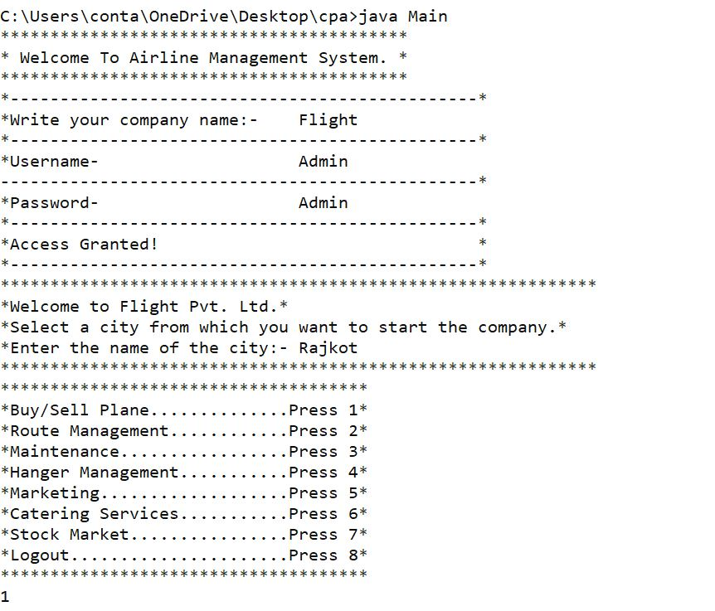 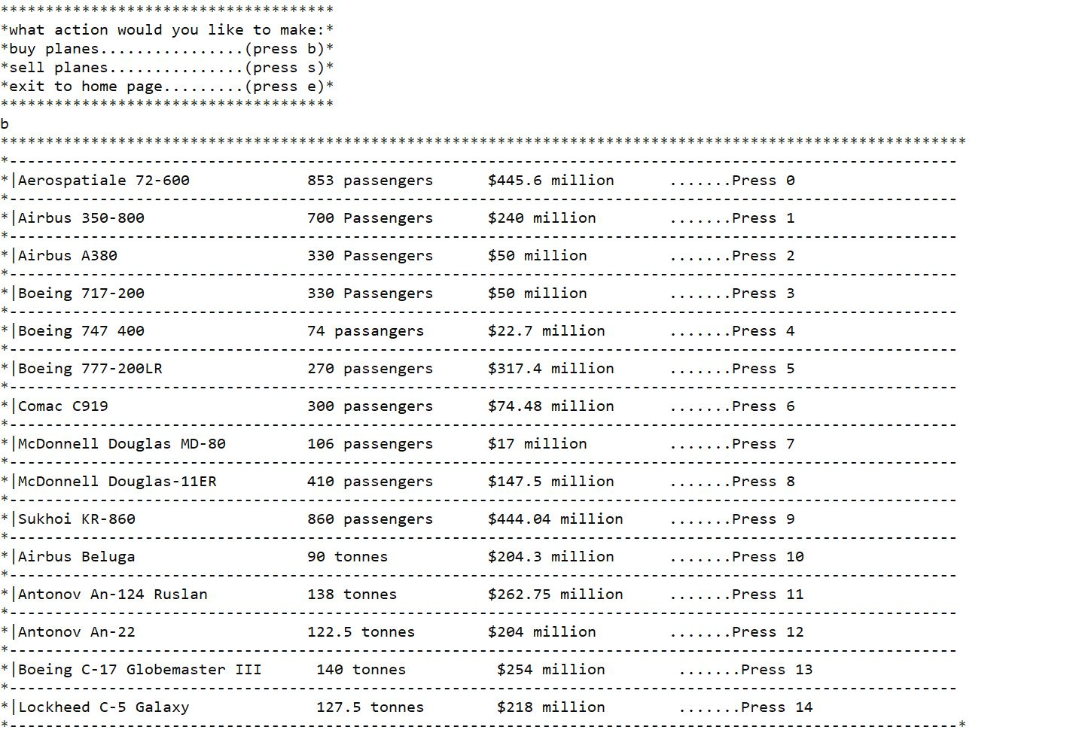

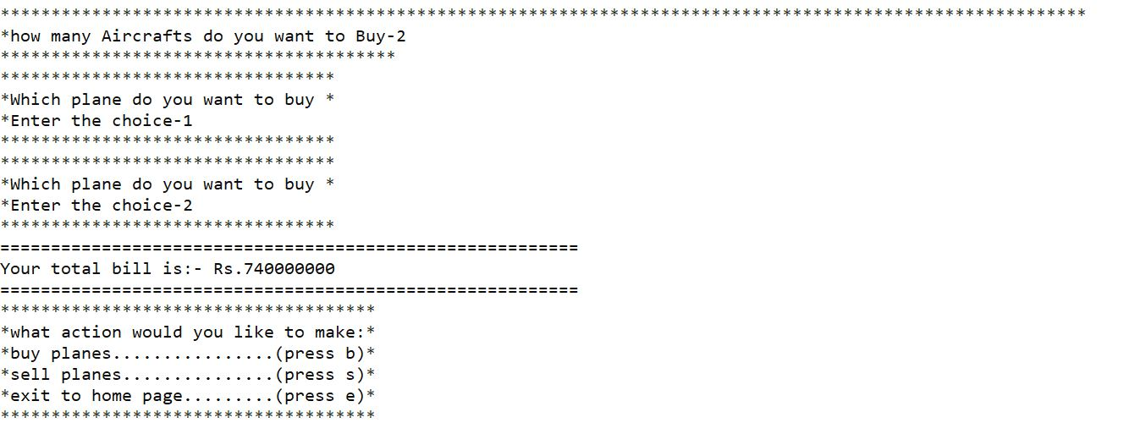

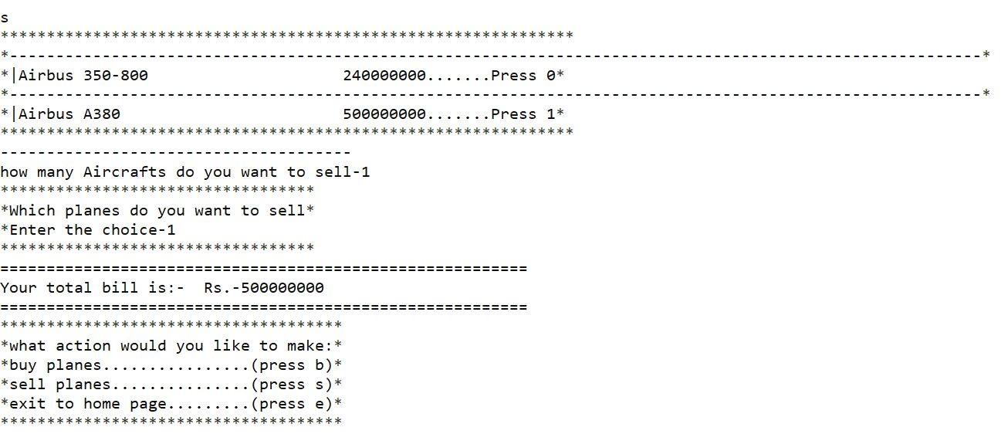

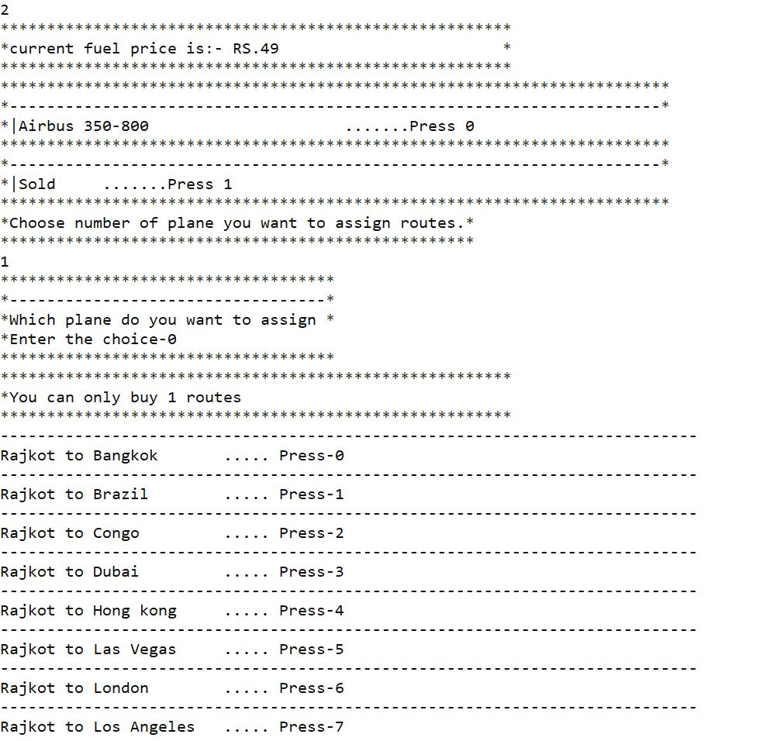 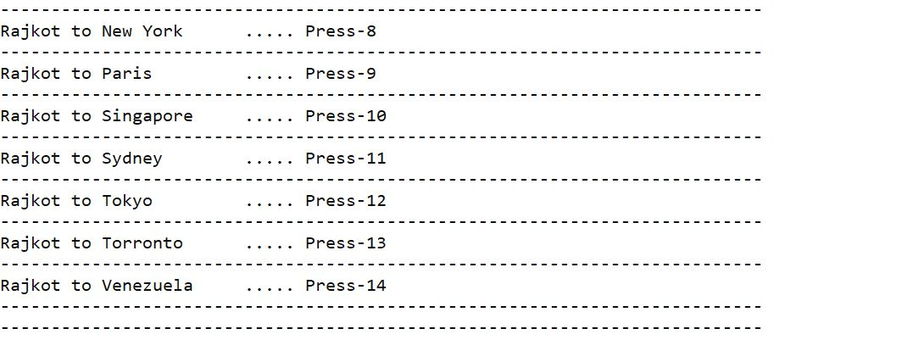

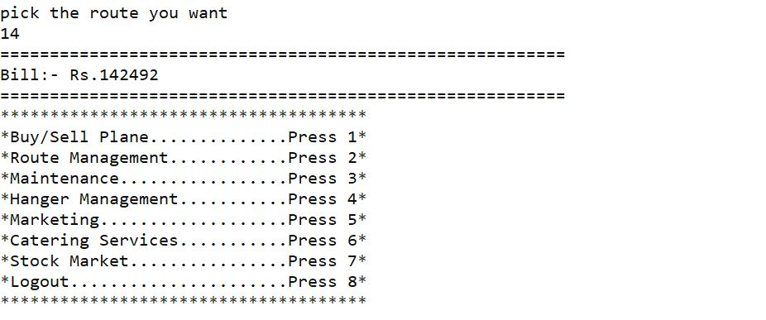

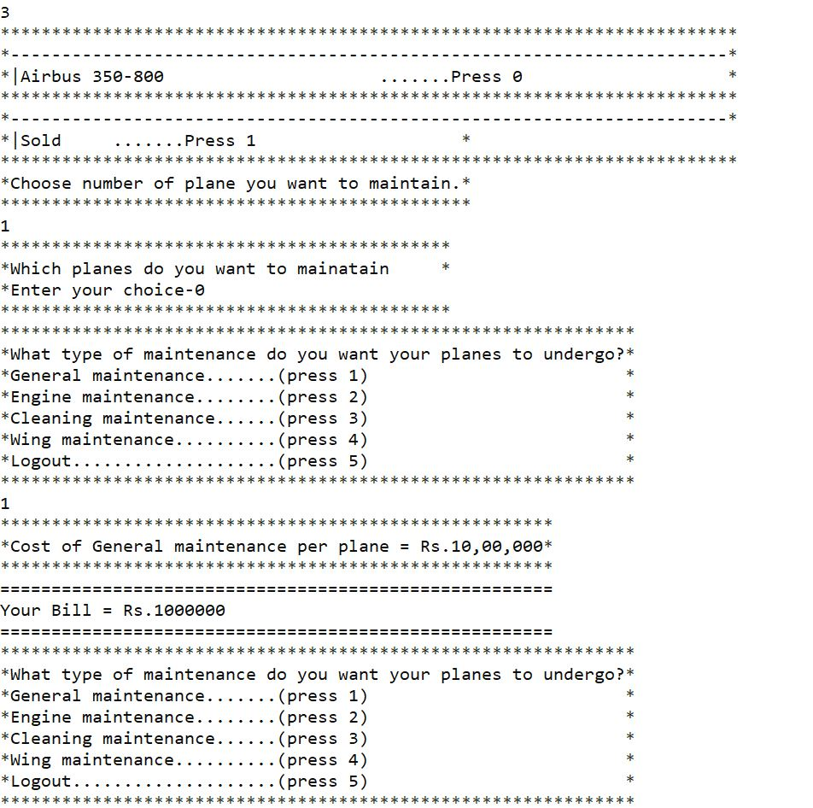

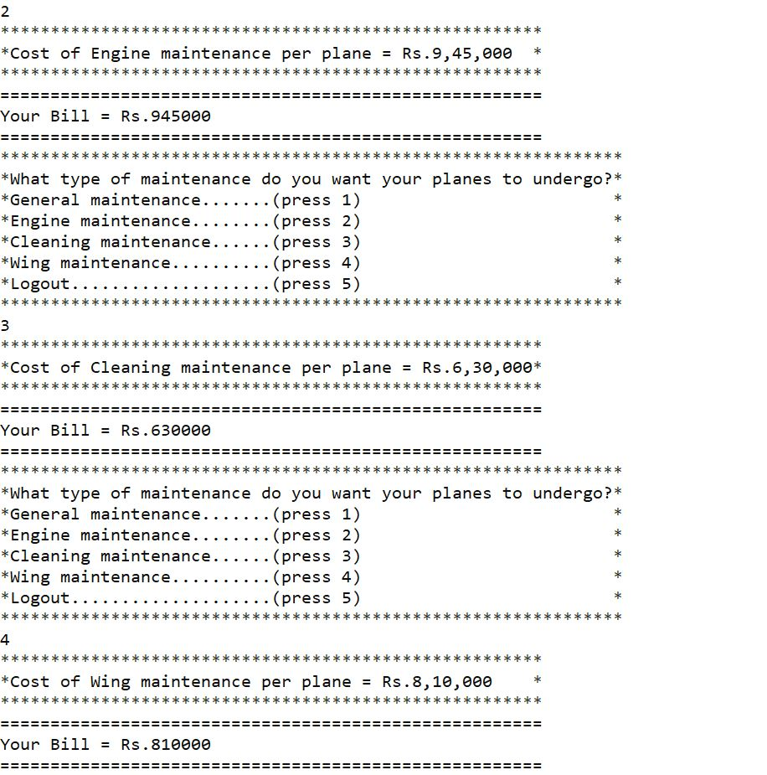

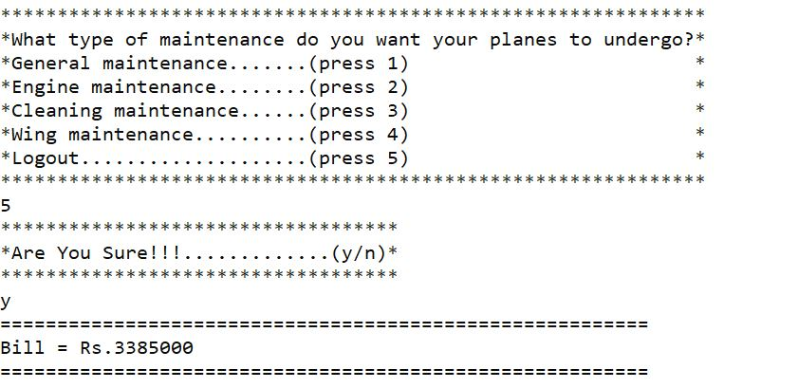

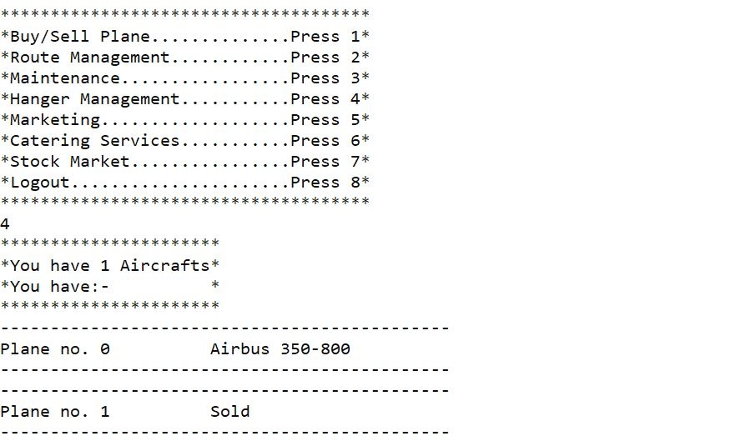

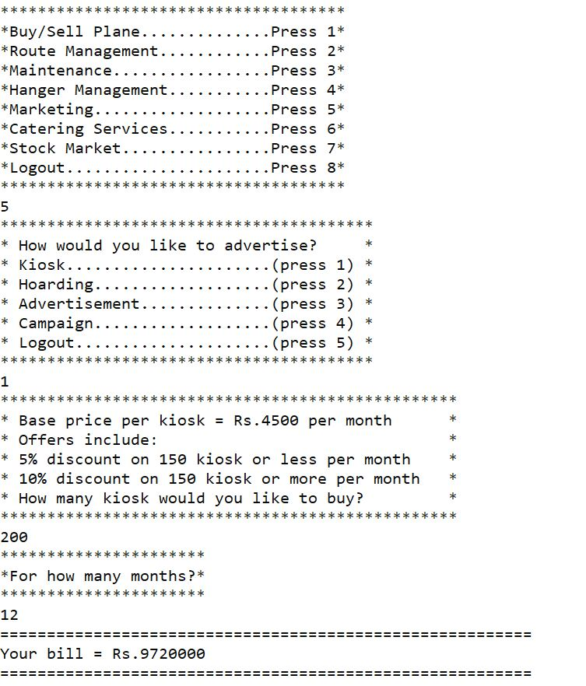

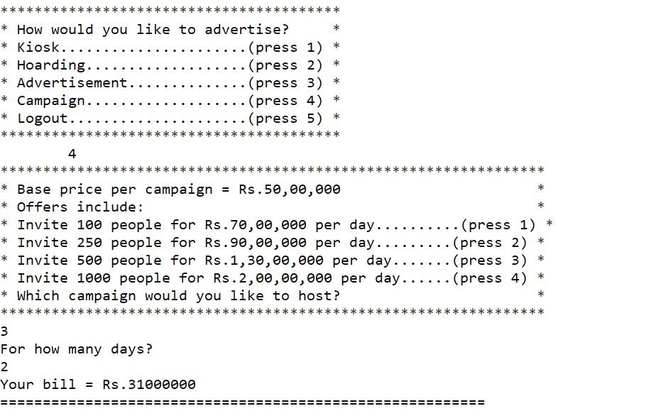

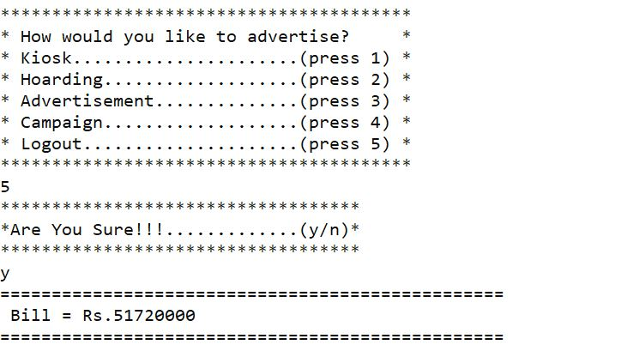

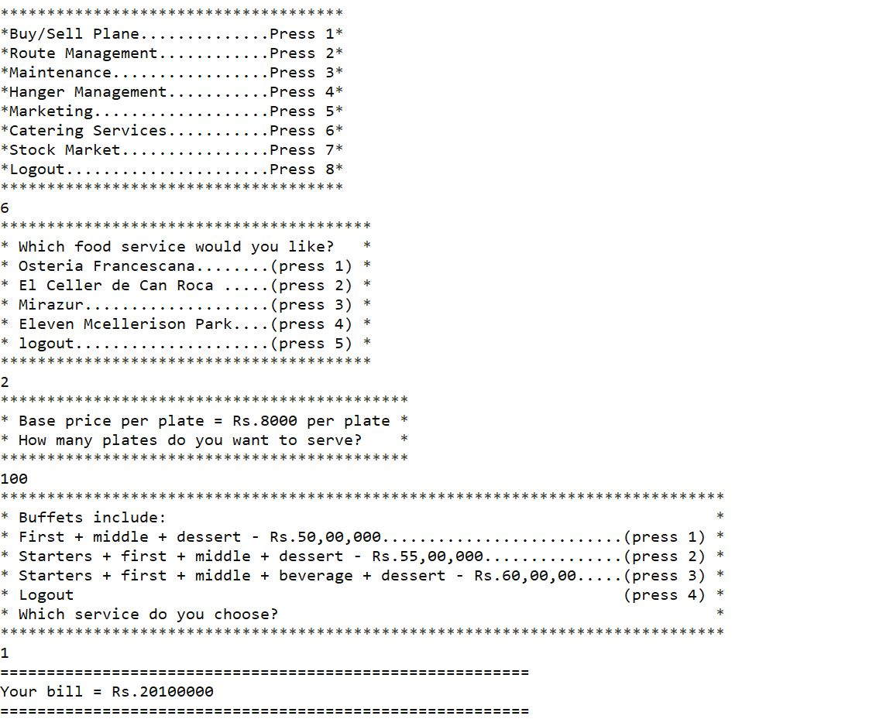

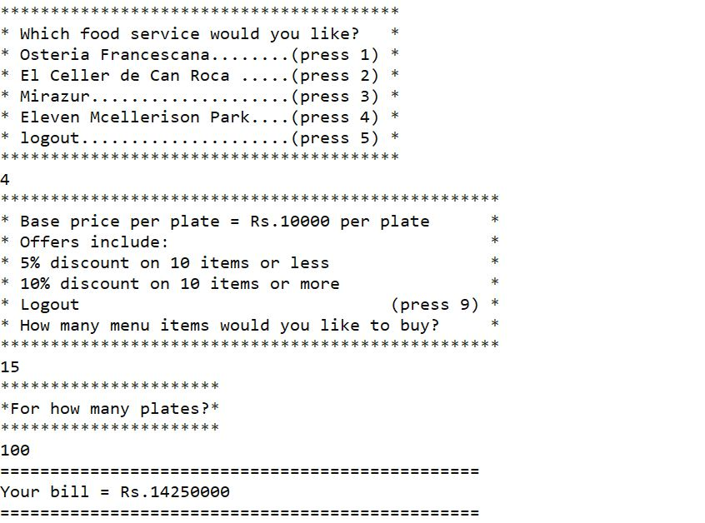

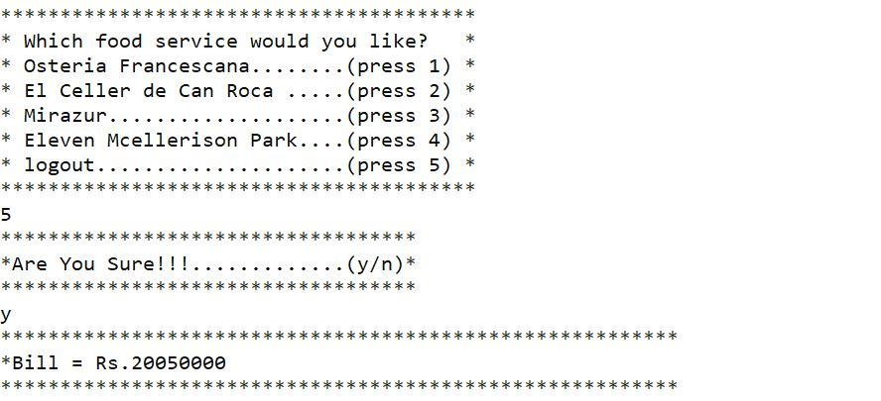

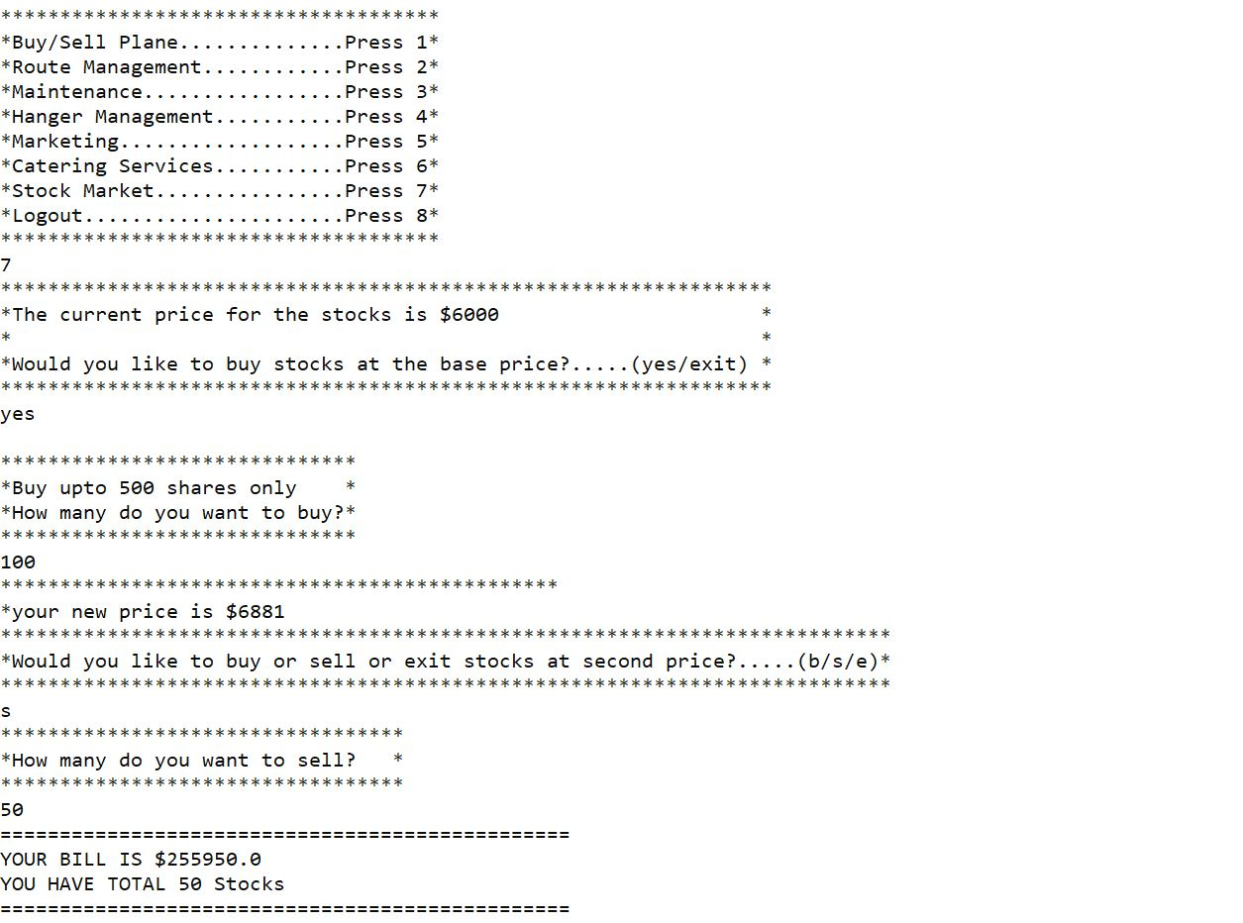

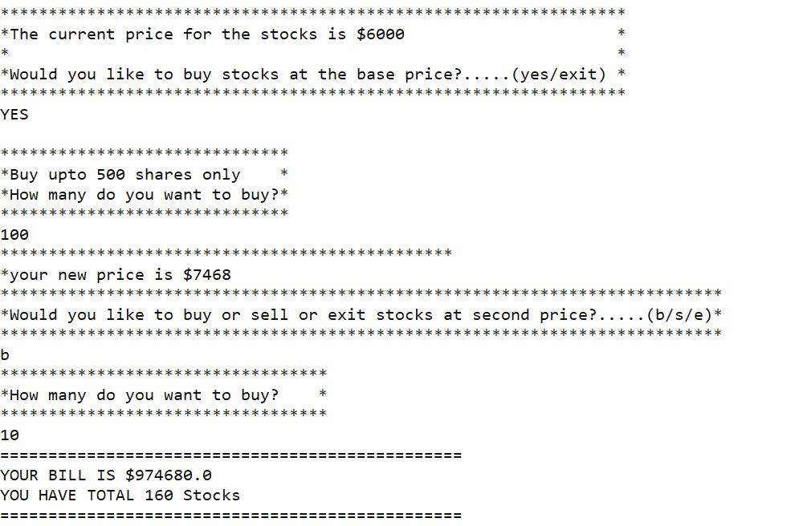

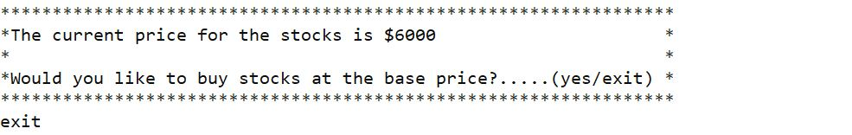

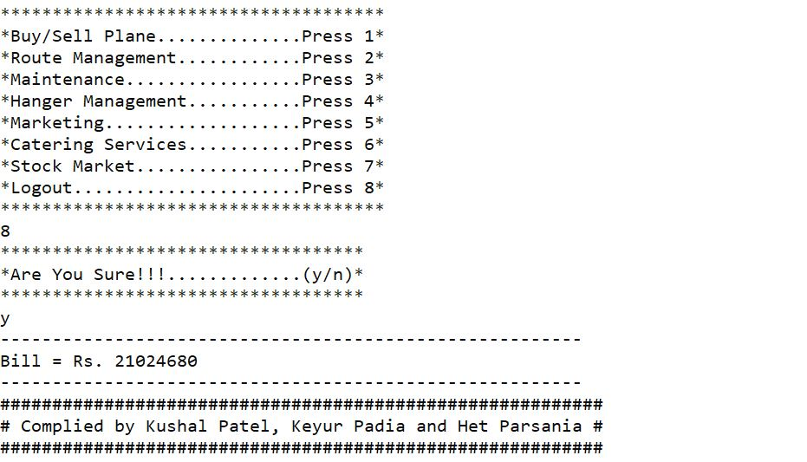

# **CONCLUSION**

We had a lot of fun while completing this project. It also made us learn new things and coding aspects we had never seen before. We learned many life skills as well as having patience, thinking straight while you don't get ideas and have a learning mindset. We also learned that in order to make a great code you must listen to the suggestions of other people as well. We have had a great experience completing this project and we hope to do such projects in the future as well.

# **BIBLIOGRAPHY**

We have learned many new things while completing this code. If you want to know more just refer to the following resources.

**Books**

ICSE computer applications class 10 by oswal publications

**Websites**

<https://apps.facebook.com/airlinemanagerx/?fb_source=appcenter&fb_appcenter=1>

[https://stackoverflow.com/java](https://stackoverflow.com/questions/tagged/java)

<https://www.geeksforgeeks.org/java-programming-basics/>

<https://www.w3schools.com/java/java_intro.asp>